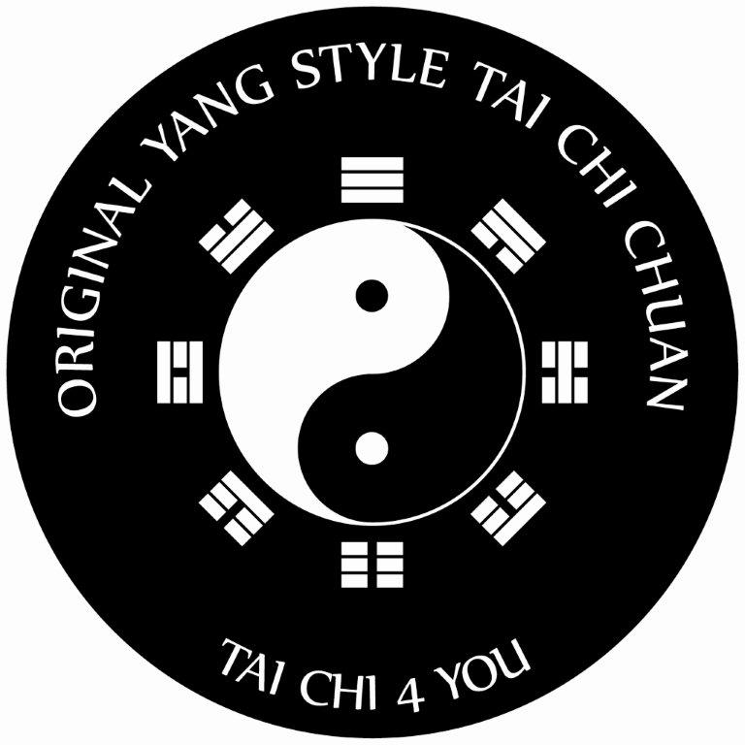
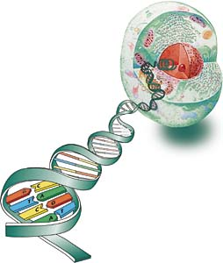

“EXERCISING THE SECRETS THAT LIE WITHIN”

The Secret to Tai Chi & Chi Kung success is the three P’s
Preparation, Practice and Perseverance.

Before discussing the three P’s I want to first say why I decided to make this contribution at all. I asked myself why is it that even after all the endlessly good tai chi books that explain the benefits of tai chi and the vast amount of case study data etc a lot of people still struggle to actually become active with tai chi itself. Of course millions of people around the world practice tai chi & qigong to various different levels of ability, time invested and progress with all simply doing it for their own reason(s). All gain the benefits from minor to major improvements with the link to the results being based on the amount of quality time and dedication to tai chi is actually done.

So this is the basis of my efforts laid out below and that is to help tai chi students to make that simple step to firstly see tai chi as part of their whole lifestyle and way of being. Encouraging them to actually do it rather than just think about doing it.

One idea is to simply write a text full of the benefits but this has been done so well by so many famous tai chi masters, Tai Chi Health for Life by Bruce Frantzis is a classic in this field and to even attempt to compete with these kind of books would be as silly as trying to redesign the circle.

So the message I wish to create is a rising of consciousness as to how to get to actually doing it and to thus overcome the collective habit of falling by the way side of good intentions.

So the following article has the direct goal of helping everyone overcome the addiction of stress itself. This is the very point of my concern and that is to show people that the lifestyle patterns that have caused you to take up tai chi classes in the first place are often the very reason why a few people stop. You see stress is not the problem it is the fact that we are addicted to stress which is the real problem. You see we are addicted to using the wrong energy, for the wrong task, at the wrong time and with the wrong thinking pattern which feeds the habit that your life style has become. The fact that the wrong hormones are in the body causes the body to tense and become tired. Ironically, the very hormones that are produced to react to the stress moment cause the body to ask for more of the same. Often, despite the stress levels we still manage to obtain the desired thing we wanted but at what cost to our self or even the planet. Achieving something by expending the right amount of chi should be the hallmark of your success and not achieving something at the expense of your own health and wellbeing. It is also worth noting that when (as we all do) we sometimes “over do it and exhaust our self, then Tai Chi & Qigong will help recover/reinvigorate your chi back to a healthy balanced level.

Think of this: One common reason for starting tai chi is because “I am too busy and stressed out.” Yes they know that it is this over the top busyness that is ruining the quality of their life! Yet in no time at all he or she will stop the Tai Chi lessons with the fatal excuse… yes you guessed it: “I am sorry I have to stop my classes because I am too busy” So my interest is focused on energising people to raise their awareness of this pattern and thus ensuring that they utilise this new consciousness to really achieve the benefits that they and everyone deserves.

I recently watched an interview with Oprah Winfrey and Erkhart Tolle (author of the Power of the Now and A New Earth) and there he reminded us all that “the road to hell is full of good intentions.” This statement clearly reminds us all that you might start something with good ideas and intensions but the lack of actually living these actions keeps you on the road of good intensions instead of the road of living life to the full with real life, health and wholeness.

On a positive note many people in their own way actually do get it! And they gradually break and let go of their old habits and find tai chi and qigong to be what it is and that is the most advanced form of exercise known to mankind. So my focus here is keep those who have grasped it and thus inspire them to stay focused and further develop and also to really focus on the mass collective who know it is good for themselves but fall quickly by the way side.

Also on another positive note many students who practice tai chi find themselves enjoying more wholesome live styles. They change to a healthy diet start reading more spiritual books or just feel more connected with life and enjoy the simple things much more than they used to.

However, for all of us, weather practicing tai chi or not, the stakes could not be any higher or more urgent. The worlds Yin Yang is perilously out of balance. Global warming is now no longer a matter of debate and we are the cause. The collective human race is embarking on a secret covert global war on Mother Nature itself. I say secret because even the most loving and caring of us are sometimes unwittingly joining in, in the unconscious contribution to our own possible demise.

So what greater motivation do you need than to know you are learning and practicing something that not only balances your own true self but will contribute to saving the planet! Let me put it to you like this. The practice of tai chi teaches you to recycle your energy. You learn that you don’t have to give all your energy away but you can circulate your own chi and do not need to draw on or drain other people’s energy. Isn’t that what we are doing with our planet right now… draining it all away? So the solution starts within.

So let’s go for it because there is no longer the luxury of time to wonder about it all.

We can attend lessons and even read some good books on the subject. But if a regular training schedule is not actually done then the results are as follows:
Your health and fitness will improve. Your one lesson a week will give you many benefits but will only be one 7th of the real benefits you can and should have. You can see it as like going for a once a week massage or weekly meditation. Anyone doing that would feel good benefits. The great benefits come once you start having the mini “massage treatment sessions” on either daiyly or regular moments throughout your week. Of course how many people could afford to have a massage or personal trainer look after you every day? = Not many. The secret is you are your own personal trainer, or should I say becoming your own personal trainer and what’s more its free :>) Make a start by thanking yourself. Once you thank yourself for practicing that one time a week, then bring this feeling of appreciation into other times of the week to steadily increase the benefits etc.

Be aware of the monkey effect: The negative spiral created by not practicing regular could run the risk that you will eventually lead to stopping training all together and thus falling back into the old patterns which made you want to take up Tai Chi in the first place. To avoid this negative spiral keep your daily focus on your health and enjoying life. The voice (the monkey within you that tells you are busy etc) is the ego itself not realising the self destruction of the negative spiral. Also the ego loves to keep us busy doing things that often don’t result in healthy lifestyles. Become aware of it and you can refocus it into positive consciousness and live out your destiny.

The basis of my message is to wish you all:
Good preparation of life’s goals and plans.
Enjoy the practice of anything you choose to do.
Persevere with your training because the rewards are truly worth the effort you put in.

Preparation:

Make Tai Chi a key part of your life. Be enthusiastic about what you are going to do and prepare well. Be aware that it is in this phase that you might fall back because in the preparation period you are coming up against all your stress addictions and an old negative thinking pattern which may well block you entering into actually the 2nd phase and that is the practice.
Part of your preparation is to know what you want: Set clear and specific goals.
Meditation of your goals: Set all your identified ideas to paper and formulate a commitment to actual DO the things you really want to do. Then spend time during the early morning hours focusing on your positive goals which you have written down.

Creative Visualization: Begin by visualising your self in excellent health. See your old “war wounds” illnesses and imbalances slowly leaving your body. Whilst of course you do not deny your current condition, you do however; picture yourself being totally full of energy and in total optimal health. See yourself having the time to practice your Tai Chi & Qigong.

Visualise yourself actually doing it. Say to yourself that you have the time to look after and enjoy yourself and also remind yourself that the more you do the more you get.
During a quiet moment at your work place you can just imagine yourself at home standing in your garden, breathing fresh air and moving freely practicing your mediation movements of your Tai Chi form. Focus your mind on the practicing as if you are looking forward to going on holiday. How many people look forward to doing that but then say “no I don’t have time to do that holiday” = not many. So your preparation is like pre-enjoying your actual training. This looking forward to doing it feeling, will increase the chance of you giving your mind body and spirit that daily/regular holiday.

Realise the old tai chi classic saying “action through none action.” So whilst you are sitting down doing nothing your mind is quietly visualising, thus the movement is inside. You have prepared yourself to flow into practice by doing nothing.

The code to achieve actual practicing is to prepare a clear and positive mind set and establish a slot in your life style where your training can take place naturally. Do things that make the ground work for your actual moment of Tai Chi. Create a user friendly home environment which will promote the feeling of having time to do what you want. At this point I can hear you saying “yes all sounds very good and I already do good preparation and want so much to practice but don’t seem to get around to it.” Well this is because you don’t have the habit to do it. I mean think of cleaning your teeth, now that’s a natural healthy habit that you do without a second thought because its just part of your natural day. Now that’s what you want your tai chi practice to become > just part of your natural day. Thus you replace old stress habits with health and harmony habits.

If you are still not training yet then evaluate the why not reason(s) and transfer to the how & when assessment. Go with the flow! Never be too fixed and rigid with your planning. Making plans is all well and good but life comes along and quickly changes well intentioned plans. So have a plan B. This will mean you are flexible and thus adapt and stay on track as you first planned.

Preparation is important but don’t ponder and plan too much. Just ensure your preparation is consistent and helps you achieve the next phase > the practice. You see, if you write a great ‘things to do’ list but don’t do it because something interrupts your plan you may be discouraged. Be careful not to become a good planner but bad at doing! Anyway give yourself time to improve, at one stage the life style habit is in built, you prepare less and you just practice without having to pre plan because that part is now going by itself.

Suggested pause: Before reading about practice stand or sit and do your tai chi exercises right now for a few minutes.

Practice:

The secret here is that it is better to be doing it and saying to your self “hey I am doing it other than thinking “hey when shall I do it, do I have time?” and all the endless time consuming thinking we allow ourselves to engage in. So just do it, either planned sessions or small spontaneous Tai Chi or Qigong moments in your daily schedule. Here is a reality check: The more you “spend time” doing Tai Chi, the feeling of having more time for life will natural follow. Tai chi is very much about being naturally aware and in the now. So when you are finished with your session of practice your state of mind is less cluttered and gives you a sensation of having more room, actual space to do or not to do your next task. Your inner and outer worlds harmonise.

So apply definite actions: Just do it. Don’t try to find time. Trying to find time is like looking for a needle in a hay stack, you will blindly be looking for the time to practice (often for hours) when the time you have is right in front of you. You already have the time because you are the time. Just like our nose on our face we can’t see it until we look in the mirror. So reflect and you will begin to see yes, although I have lots of things in my mind to do I do have time. Just do your tai chi moves or qigong. If truly time is the issue then review the preparation step as this may well need looking at.
So take definite action, yes, just without to much thinking just start moving and steadily move into your practice of that moment. Spontaneously start action. Often how long you train can better be decided whilst you are actually training and not pre planned.

Also, create a few moments in the day when it is just you doing nothing. Just simply standing or sitting and focusing on your breathing. You might be doing a boring task like ironing or washing up etc why not practice tai chi exercises (qigong standing posture) at the same time you are doing these necessary but time consuming tasks. Here you build chi whilst doing two things at once. Always remember: the key is action!
Then just do it! Yes Practice. Don’t set too high a standard for yourself and do what you can when you can. At first this may feel time consuming and even tiring but quickly you’ll find that the more you practice the less tired, less stressed you feel. Ironically by spending the time to do it this creates the feeling of having more time to face the busyness of life. Tai Chi gives you more energy whilst keeping you enjoying your life. This joy is your birth right and tai chi “doing” is one proven way to truly enjoy life and cope with its challenges that come along. Tai chi can be practice even whilst doing any other task or sport. Whilst you sit and read a book you can also benefit from doing this in a relaxed and natural posture which you have re-learned thanks to your Tai Chi weekly lessons.
Important note of reflection: If you have read this after having practiced tai chi for 10 minutes to an hour or so then you are already “getting it” and this text might well help you be aware of the pitfalls and also keep you on track. If you are reading this and haven’t just practiced before reading it then simply put the paper down and do it then return to finish the text. I suspect that we westerners allow ourselves to become arm chair experts and the Chinese people or wiser ones do first and read later

Suggested pause: Before reading about perseverance stand or sit and do your tai chi exercises right now for a few minutes.

Perseverance:

Keep focused and consequent with yourself. Doing Tai Chi is an act of natural personal love for your self, indeed for everyone else and of benefit to the planet itself. Be consequent. All you need to do is keep it going with a inner joy and happy feeling and gratefulness of all that you do and have.

Also know, it is not you and Tai Chi because you are Tai Chi itself. Tai Chi is an integral part of your life because tai chi is the way of living and not a movement that you must do. What I mean is you are yin and yang it is just that the geniuses that devised tai chi and qigong knew this and that the principles of tai chi movements will help maintain and ensure that you return to the real self. The self = I, that is, was and always will be Wu chi, Yin Yang and the Tao.

Some days it will go well and other days not so well. You will experience all kinds of emotions along the way but always remember what a great friend your Tai Chi will be. Above all persevere with a combination of happy chi and willpower. Note: happy joy chi is far more vital than willpower because willpower can run out but real inner joy is endless.
Health just like most things in life is gained through the continuity of making the correct choices we make and things we do in our daily life. Having said this, sometimes bad health can come along either by an accident, a chain of events or even as part of our DNA programmed karma. Even so what is so vital is what we do and how we think. Both prevention and curing both require this.
Like the monkey voice in the preparation phase, be aware that just as you start to feel good and notice good changes etc then this monkey voice pops along and comes up with amazing reasons why you should stop or do less etc. This is sadly the ego that does not realise its damaging effects. Things like “I practiced yesterday so I don’t need to today “ or “I am not good enough, and they all do it better than me” “Do I have enough time” missing this lesson won’t matter” etc etc the list goes on. Meditate on the motive of these thoughts and you will again see them for what they are. Also always listen and respect your positive inner voice that says “I feel like a quick workout” Quickly act on this and just do it that’s the big secret of secrets the practice of what is good for you and fellow human beings.
Above all to persevere you need to stay enthusiastic, inspired and both conscientious and conscious of what, why, how and all the benefits etc. This buzz comes during your actual classes and your reflection of what you saw and learnt. Ensure you always have some of the great tai chi books to hand or videos, train with fellow tai chi students and observe nature because all these things just mentioned will keep you going through both so called ‘high moments’ and the ‘lower moments’ we all have.
Both prevention and improvement of life quality are two excellent motivators. If ever you wonder the reason why you do it just look around at your children or grandchildren and you realise that you are also doing it for them. By looking after yourself and being in the best health and balance you can manage you simultaneously take care of them as well as yourself. Children get the benefits from seeing you looking and feeling so good.
“Prevention is better than the cure” says it all. However, with the application of preparation, practice and perseverance you can indeed enjoy a rewarding, happy and fulfilling life style. I would not dare to claim that just these three principles will be the answer or are the way of focusing you but hopefully the three P’s article will inspire you to see where I am coming from!
Whilst cycling home from one of my morning classes it came to me that the three P’s are in fact all as one. When you are in preparation mode, you are really also practicing (psychologically) and need to persevere even as you prepare and when you are practicing you need perseverance to keep going and the perseverance leads in back and helps during the preparation mode thus all being linked as one.
Thought: Longevity is not just about living longer; it’s about living a longer and deeper meaningful life where you become conscious and enlightened. Tai Chi & Qigong offers natural comprehensive methodology for enriching the quality of the life you have succeeded in extending.
The more you focus on your health the more you keep increasing the benefits of your tai chi and keep progressing. However, if you some times think of stopping training or wonder why you are doing it, quietly reflect on your lifestyle and remember how you originally felt plus why you started in the first place. This reflection should guide you back on track. Apply the tai chi energy redirection principle. Your emotions give or take away your natural energy = so positive emotions create energy leading to action the action creates more positive emotions. So if you are experiencing a negative ‘shall I stop’ emotions then think and feel it through. Yes imagine its results, go with this feeling and see were it is leading you to! For we have positive or negative emotions. Seeing this negative emotion for what it is and see where those actions will take you!! You will quickly think whoops! Don’t want to end up like that.

These emotions are either from external circumstances or coming from your own ego either way they are your own choice. You will create the corresponding results based on what your emotions are and what you chose to do.
In Tai Chi we use the principle of non resistance. The more you resist something the more the problem grows, the more you tense and the more tired you become. When you are thinking shall I stop, look at that thought and say is this good advice which will promote my health or is it just a negative thought that takes my health away.

Tai Chi teaches us to see the positive in the negative. Even when we have a dip in emotions we can learn a lot about ourselves and this so called dip is made worse because the personal ego is resisting the changes that are developing.

The act of personal love and looking after your self is ensuring that your lifestyle/practice schedule is relevant to your busy stressful job schedule. It is vital that you have important moments were you can actually relax, practice tai chi and qigong. Often being good at your job brings even more work and increased expectations leading to stress levels that then stop you being good at your job. Just ensure that the more successful your career is then the more important it is to have that energy balance practice moment. Doing this wonderful internal art will develop you and connect you to your real being like never before and also connect you to loved ones and this wonder we all call planet earth.

My dream, but so far not yet fulfilled, is getting more people to practice tai chi and qigong as part of their daily/weekly lifestyles at home. Many of my students now practice regularly at home and report the increased benefits of doing this. But I am also happy to know that my students, that only practice once a week, also gain benefits. For them I wish to “inspire to require,” to do more to get more.

My Stewart family motto is “never despair.” So I will always work to fully realise this dream into reality. Stay on your path, your own unique journey and thank you for taking the time to read this article. So, I hope it manages to inspire you and help you to practice, practice and practice. Wishing you good health and happy chi. Remember: Tai Chi is you and for you :>) enjoy this art of living!

Suggested pause: After reading about this article again stand or sit and do your tai chi exercises right now for a few minutes. Good habits need to start sometime and somewhere > this is it!
Date 10-06-2008. Written by: Tony Stewart. All rights reserved.
Tai Chi 4 You School of Original Yang Style Tai Chi Chuan
Instructor: Tony Stewart KvK Nr. 60116853.
Tel: 06 26906168 0164 854568.
E-mail: info@taichi4you.nl www.taichi4you.nl

